Costs of Production
Unit 4.2 Questions

- Betty Marshall runs a small jewelry shop in Havanna, producing necklaces. She has the following monthly costs:
  - Rent - $300
  - Jewels - $150 per necklace
  - Machinery - $30
  - Monthly Wage - $100
  - String - $5 per necklace
  - Electricity - $40
  - Beads - $10 per necklace
Which of her costs are fixed and which are variable?
- If she produced 100 necklaces what would her fixed costs be?
- If she produced 100 necklaces what would her variable costs be?
- What are her Total Costs when producing 1 necklace?
- What are her Total Costs when producing 319 necklaces?
- Fill in the table below

Necklaces produced | Fixed Costs $ | Variable Costs $ | Total Costs | Average Costs
0

50

100

200

300

400

500

- Draw the above table out on a graph, without Average Costs. Be careful with scale. You may need to break scale in order to fit everything in (for example, go up in 100s until 500, and then go up in 5000s)!

- Imagine her costs looked as they do below. If Ms Marshall charged $80 per necklace, fill in the table below

Number of Necklaces sold | Total Revenue | VC | FC | Total Costs | Profit/Loss
0 |  | 0 | 200
5 |  | 350
10 |  | 500
20 |  | 700
30 |  | 900
40 |  | 2000

- Draw Total Revenue and Total Costs out on a graph
- Mark in the area of profit/loss
- Mark the break-even point on your graph
- Would the firm have to shut down in the short run if producing 5 units? Explain your answer
- What is the margin of safety (roughly) when the company is producing 30 necklaces?
- If fixed costs increased by $100, show this would affect the curves on your diagrams.
- What effect does this have on the break even point?

Revision Card Summary

Fixed Costs

Variable Costs

Average Costs

Total Costs

Break even point

Margin of Safety

Total Revenue

Profit

Loss

Costs of Production Extension
Unit 4.2 Extension Questions
1. Look at the break even chart below. Explain what would on the chart if:
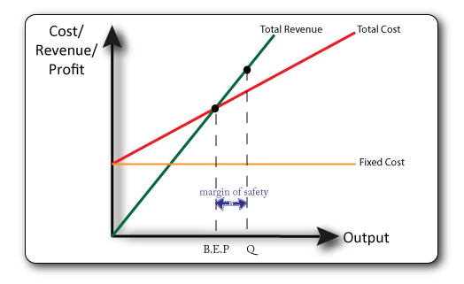
  - Prices rose for the company
  - Rent rose for the company
  - The company sold fewer units
  - The company’s production costs fell
- Explain three limitations of a break-even chart [6]

